

Rosanna Cubs
FIRST Pack Holiday!
Mt Martha
Fri 14th-Sun 16th Nov, 2008


Details for Attendees

Ahoy me hearties! It’s time for Rosanna Cub Scouts FIRST ever Pack Holiday. To keep hidden from those blasted Redcoats, our pirate ship is cleverly disguised as railway carriages, moored by the bay in Mt Martha! We need a new crew since the last lot took off with some buried treasure.... and you’ve now signed on as our new Crew! Come aboard as we sail the high seas of Port Philip Bay and beyond.... to cause mayhem and make ourselves rich!

Location: Joseph Harris Scout Park, Hearn Rd, Mt Martha
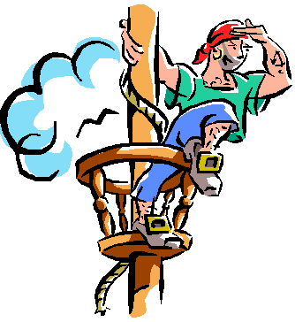
About it: We will be staying in the Railway Carriages – three ‘red rattler’ train carriages and adjoining undercover ‘station platforms’. Accommodation is 2 rooms of 8, 2 of 6 and 3 of 2. Also, Kitchen, dining car, recreation car, toilet and shower facilities. The Scout Park is in a bush setting with plenty of onsite activities for our Pirates to undertake!
Transport: We will be travelling by bus and car – approx 2-3 cars will also be going.
Cost: $80 – includes transport, accommodation, food and activity equipment
Leaders: Leader in Charge: Wayne Renfrew
Assistant Leaders: Laura Renfrew, David Bonner
Cooks: Kaye Norman-Bonner, Meredith Begg
Depart: Meet at the Scout Hall at 6pm, Fri 14th Nov. - Ready for a 6:30pm departure.
Return: 1:45 pm Sunday, 16th November – depart from Mt Martha
3:15-3:30 pm arrive back at Scout Hall.
Take: Kit list for Dormitories is available on the paperwork/downloads page of our website. Eating Kit/Dilly Bag not required.
PLEASE NOTE: All our Pirates will need to bring an appropriate costume for Saturday night! ALSO, very old clothes for the High Seas Pirate (flour) Battle!
Health Form: ALL ATTENDING MUST BRING A FILLED OUT HEALTH FORM ON FRIDAY!!!
– see our paperwork/downloads page
NO: Phones, MP3 players, electronic games, radios or similar may not be taken.

Please return the balance owing to Cubs this week…. For most that will be $60. For those who have not yet paid their deposit, full payment of $80 is now required.


Regards

The Leaders
Rosanna Cub Scouts See us at http://www.rosannacubs.org

